<Enter project name here>
System Requirements Specification
Version <1.0>
mm/dd/yyyy

Total (100%)

Document Control

Distribution List
The following list of people will receive a copy of this document every time a new version of this document becomes available:
Teaching assistants:
<list names>
Customer(s): <list names>
Project team members:
<list names>

Change Summary
The following table details changes made between versions of this document:
Version | Date | Modifier | Description

Table of Contents

Document Control 1
Distribution List 2
Change Summary 2
1. Introduction 3
1.1. Purpose and Scope 4
1.2. Intended Audience and Reading Suggestions 4
1.3. Document Conventions 4
1.4. Project References 4
1.5. Definitions, Acronyms, and Abbreviations 5
1.5.1. Definitions 5
1.5.2. Acronyms 5
1.5.3. Abbreviations 5
2. General Description 5
2.1. Product Perspective 6
2.2. Product Features 6
2.3. User Classes and Characteristics 6
2.3.1. Actors 7
2.3.2. Use Cases 7
2.3.3. Scenarios 8
2.4. General Constraints 8
2.5. Operating Environment 9
2.6. User Documentation 9
2.7. Assumptions and Dependencies 9
3. External Interface Requirements 9
3.1. User Interfaces 10
3.1.1. Mobile User Interface 10
3.2. Hardware Interfaces 12
3.3. Software Interfaces 12
3.4. Communications Interfaces 12
4. Behavioral Requirements 13
3.1. Same Class of User 14
3.2. Related Real-world Objects 14
3.3. Stimulus 14
3.3.1. Mobile App Stimulus 15
3.4. Related Features 15
3.5. Functional 15
5. Non-behavioral Requirements 16
5.1. Performance Requirements 17
5.2. Safety Requirements 17
5.3. Qualitative Requirements 17
5.3.1. Availability 17
5.3.2. Security 18
5.3.3. Maintainability 18
5.3.4. Portability 18
5.4. Design and Implementation Constraints 18
6. Other Requirements 19
6.1. Database Requirements 20
6.2. Operations 20
7. Analysis Models 20
7.1. Data Flow Model 21
7.1.1. Data Sources 21
7.1.2. Data Sinks 21
7.1.3. Data Dictionary 21
7.1.4. Context Diagram (Level 0 Data Flow Diagram) 22
7.1.5. Level 1 Data Flow Diagram 22
7.1.6. Level 2 Data Flow Diagram 23
7.2. Class Model 23
7.3. State Model 24
8. Impact Analysis 25

Introduction (7%)

Purpose and Scope
<< Insert a brief description of the purpose of the SRS. Describe the scope of the product that is covered by this SRS, particularly if this SRS describes only part of the system or a single subsystem. Identify the system products to be produced, what they will do, and describe the uses for the system, including benefits, objectives and goals. This paragraph will briefly state the purpose of the system to which this document applies. It can describe the general nature of the system and summarize the history of the system development.
Include the following:
- Identify the system to be produced by name.
- Refer to and state the result of the earlier finalized needs analysis, in the form of a brief but formal expression of the customer’s problem(s). Explain what the system will and will not do to satisfy those needs.
- Describe the application of the system being specified. As a portion of this, it should describe all relevant top-level benefits, objectives, and goals as precisely as possible. >>

Intended Audience and Reading Suggestions
<< Describe the different types of reader that the document is intended for, such as developers, project managers, marketing staff, users, testers, and documentation writers. Describe what the rest of this SRS contains and how it is organized. Suggest a sequence for reading the document, beginning with the overview sections and proceeding through the sections that are most important to each reader type. >>

Document Conventions
<< Describe any standards or typographical conventions that were followed when writing this SRS, such as fonts or highlighting that have special significance. For example, state whether priorities for higher-level requirements are assumed to be inherited by detailed requirements, or whether every requirement statement is to have its own priority. >>

Project References
<< This section provides a bibliography of key project references and deliverables that have been produced before this point.
List any other documents or web addresses to which this SRS refers. These may include user interface style guides, contracts, standards, other system requirements specifications, use case documents, or a vision and scope document. Provide enough information so that the reader can access a copy of each reference, including title, author, version number, date, and source or location. Note: some specific readers may need certain references that others don’t.
Example: airport xyz layout photos, FAA documentation, specific standards (i.e., DO-178C), API references, etc.>>

Definitions, Acronyms, and Abbreviations
<< Supply a glossary of all terms and abbreviations used in this document. If the glossary is several pages in length, it may be included as an appendix. >>

Definitions
<< Provide a list of terms and definitions that may be required or be helpful to the intended audience. >>
This section lists terms used in this document and their associated definitions.
Table 1: <Caption>
Term | Definition
Total impulse | A measure of the overall total energy contained in a rocket motor

Acronyms
<< Provide a list of used acronyms and their associated definitions. >>
This section lists the acronyms used in this document and their associated definitions.
Table 2: <Caption>
Term | Definition
SDD | System Design Document

Abbreviations
<< Provide a list of used abbreviations and their associated definitions. >>
This section lists the abbreviations used in this document and their associated definitions.
Table 3: <Caption>
Term | Definition
e.g. | For example

General Description (15%)

Product Perspective
<< Provide a description of this product, where it fits into the customer’s organization’s overall structure, and what functionality is provided by this product. This section places the product to be developed in perspective with other related products. Describe the context and origin of the product being specified in this SRS. For example, state whether this product is a follow-on member of a product family, a replacement for certain existing systems, or a new, self-contained product. If the product is independent and self-contained, this should be stated. If it is a component of a larger system, the relationship to the larger system should be stated and the interfaces defined. If the SRS defines a component of a larger system, relate the requirements of the larger system to the functionality of this software and identify interfaces between the two. A simple diagram that shows the major components of the overall system, subsystem interconnections, and external interfaces can be helpful. >>

Product Features
<< The main features of the system should be summarized and organized in a way that makes it understandable to the customer or the reader. Use graphical methods to show the different functions and their relationships. Give an overview of the essential features that are important to this product. Use case diagram and descriptions should be included in this section. >>

User Classes and Characteristics
<< This section should identify each type of user of the system (by function, location, type of device), the number in each group, and the nature of their use of the system. State any user characteristics that may be influential or significant in the structure of the product. Certain requirements may pertain only to certain user classes. Include possibly important characteristics such as educational level, experience level, privilege levels, and technical expertise as necessary.
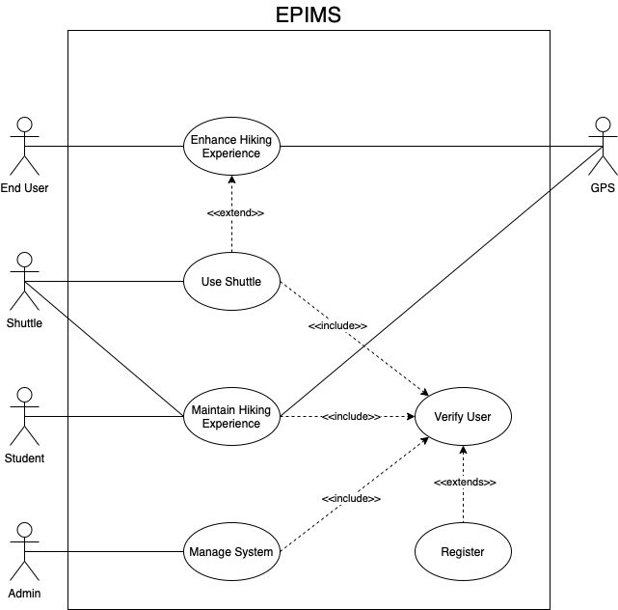
Figure 1. Use Case diagram of the system

Actors
This section presents the actors in the system.
- End User
  - An End User is the user which uses the system for enhancing their hiking experience.
- Student
  - A Student is the user which initially populates and later maintains the system’s information.
- …

Use Cases
This section presents the Use Cases, developed for the system.
- Enhance Hiking Experience
  - End Users use the system to enhance their hiking experience. The system provides various types of information and services to accomplish that task.
- Maintain Hiking Experience
  - Students populate and maintain the system by uploading information which will be displayed to the End Users.
- …

Scenarios/ConOps
This section presents scenarios for each Use Case and/or Concept of Operations, described in the previous section.
Scenario 1: Register
Description: The user creates an account to use advanced features of the system.
Actors: Current User (can be an Admin, Student, Shuttle, or an End User).
Precondition: The system has been launched and has internet connectivity.
Trigger Condition: The user chooses to create an account.
Steps:
- The system prompts the user to create a username and password.
- The current user inputs a username and password.
- The system verifies that the username and password are valid (ALT 1).
- …
(ALT 1)
3.1. The system fails to verify a correct username or password.
3.2. The system notifies the current user that the username and password are invalid.
3.3. Use case continues at step 2

Scenario 2: Verify User
Description: The system verifies the user’s identity.
Actors: Current User (can be an Admin, Student, Shuttle, or an End User).
Precondition: The system has been launched and has internet connectivity.
Trigger Condition: The user chooses to sign in.
Steps:
- …
(ALT N) … >>

General Constraints
<< State any known constraints. Explain factors that constrain the options of the development team including organizational factors, hardware limitations (timing requirements, memory requirements), interfaces to other applications, specific technologies, tools, and databases to be used, parallel operations, language requirements, design conventions or programming standards, or safety and security considerations. These may include constraints such as:
“The system will be accessible in the field.” or
“The system will not be accessible to unauthorized users.” Note: the term “unauthorized users” should be defined in Section 1.5.1 of the SRS).
These constraints are more general and may be elaborated in other sections of the SRS. >>

Operating Environment
<< Describe the environment in which the system will operate, such as the temperature, light levels, hardware platform, operating system and versions, and any other hardware/software components with which it must peacefully coexist. >>

User Documentation
<< List the user documentation components (such as user manuals, on-line help, and tutorials) that will be delivered along with the system. Identify any known user documentation delivery formats or standards. >>

Assumptions and Dependencies
<< This subsection should list each of the assumed factors (as opposed to known facts) that affect the requirements stated in the SRS. These factors are not design constraints on the software. These could include third-party or commercial components that you plan to use, issues around the development or operating environment, or constraints. They are assumptions and dependencies that if changed, will affect the requirements of the SRS. For example, an assumption might be that a specific operating system will be available on the hardware designated for the software product. If, in fact, the operating system is not available, the SRS will then have to change accordingly.
Examples:
The development team has made the following assumptions:
- The source code will be provided to the organization.
- The organization will provide the correct MATLAB signatures for the following:
  - aimpoint and detection module,
  - obscurants module, and
  - change resolution module.
- The organization will provide unclassified mockups of the modules listed above for testing and integration. >>

External Interface Requirements (10%)
<< This section contains the specification of requirements for interfaces among different components and their external capabilities, including all its users, both human and other systems. The characteristics of interfaces to systems under development, or future systems, should also be included. Any inter-dependencies or constraints associated with interfaces should also be identified (e.g., communication protocols, special devices, standards, fixed formats). Each interface may represent a bi-directional flow of information. Use a graphic representation of the interfaces when appropriate for the sake of clarity. >>

User Interfaces
<< Characteristics of each interface between the system and its users. This should specify the following:
- The logical characteristics of each interface between the software system and its users. This includes those configuration characteristics (e.g. required screen formats, page or window layouts, content of any reports or menus, or availability of programmable function keys) necessary to accomplish the system requirements.
- The logical characteristics of each interface between the hardware system and its users. This includes those configuration characteristics (layout of buttons, dials, screens, switches, or other hardware for interacting with the user) necessary to accomplish the system requirements.
- All the aspects of optimizing the interface with the person who must use the system. This may simply comprise a list of do’s and don’t on how the system will appear to the user. One example may be a requirement for the option of long or short error messages. Another example may be a requirement for the inclusion of a safety cover on a particular switch. Like all others, these requirements should be verifiable, for example, “A clerk typist grade 4 shall be able to do function X in z minutes after the introductory training session” rather than “A typist shall be able to do function X.”
Examples:
[REQ-3] The system shall gray-out and disable any visible GUI elements that are not applicable to the context of the functionality being performed. See Appendix F for settings.
[REQ-4] Hover text shall be displayed in sentence case.

Mobile User Interface

Login Screen
[REQ-2] The system shall contain a Login Screen page as shown in Figure 3.
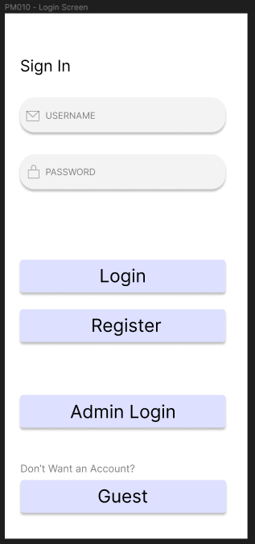
Figure 3. Mobile Login

Invalid Login Popup
[Req 3] The system shall contain an Invalid Login Popup page as shown in Figure 4.

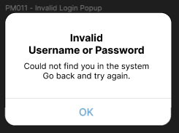
Figure 4. Invalid Login

Register Screen
[Req 4] The system shall contain a Register Screen page as shown in Figure 5.

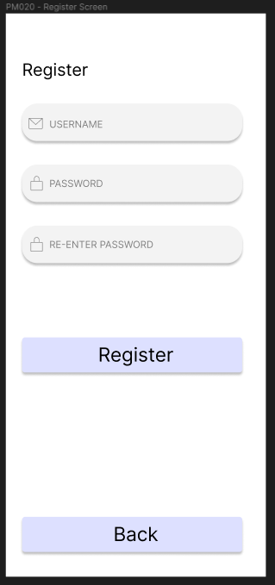
Figure 5. Register
.. And so on. >>

Hardware Interfaces
<< Characteristics of each interface between the hardware components of the system (required wires, communication protocols, etc), and possibly the software components, e.g., configuration characteristics (ports, instruction sets, devices to be supported).
This should list things like:
- physical connector specifications (jumper wires, RJ45)
- communication protocol standard (I2C, SPI, Ethernet, custom protocol)
- voltage ranges
- any other information required >>

Software Interfaces
<< This should specify the use of other required software products (for example, a data management system, an operating system, or a mathematical package), and interfaces with other application systems (for example, the linkage between an accounts receivable system and a general ledger system). For each required software product, the following should be provided:
- name,
- mnemonic,
- specification number,
- version number, and
- source >>

Communications Interfaces
<< This should specify the various interfaces to communications such as local network protocols, etc. >>

Behavioral Requirements (30%)
<< This template illustrates the organization of functional requirements for the product by requirement category. You may prefer to organize this section instead by use case, mode of operation, user class, object class, functional hierarchy, or combinations of any of these. Choose the format that makes the most sense for your system. >>

Same Class of User
<< Some systems provide different sets of functions to different classes of users. For example, an elevator system presents different capabilities to passengers, maintenance workers, and fire fighters. The class of user corresponds to the actors of your use cases. >>
Example specifications are:
[REQ-61] The system shall have three levels of access privileges: Restricted, Basic, and Advanced.
[REQ-62] User access privilege level shall be stored in the Access Table using the following codes:
- 1: Restricted
- 2: Basic
- 3: Advanced >>

Related Real-world Objects
<< Objects are real-world entities that have a counterpart within the system. For example, in a patient monitoring system, objects include patients, sensors, nurses, rooms, physicians, medicines, etc. Associated with each object is a set of attributes (of that object) and functions (performed by that object). These functions are also called services, methods, or processes. Note that sets of objects may share attributes and services. These are grouped together as classes. Use the models that the team generated from stakeholder needs analysis to drive the organization of this section.
Example:
[REQ-64] The object model for the system, given in Appendix C, depicts the entities modeled by the system and the relationships among them. This section describes the requirements related to the main objects of the system.
[REQ-65] The origin of a graph shall represent the northwestern-most point on the scene, where the pixel coordinate convention shall be (row, column).
[REQ-67] The origin of the axes shall display in the upper-left hand corner of the scene >>

Stimulus
<< Some systems (e.g., real-time systems) can be best organized by describing their functions in terms of stimuli. For example, the functions of an automatic aircraft landing system may be organized into sections that include the following loss of power, wind shear, and sudden change in roll. The state diagram, event diagram, or other dynamic model is included in this section. >>
Examples:
[REQ-71] If a workspace file is not specified in the Metafile table for the scene being opened, the system shall set the parameters for each window as specified in Table F-1 in Appendix F to their corresponding default values when the scene is opened.
[REQ-72] If a workspace file is loaded when a scene is first opened, the system shall set the default values to those specified in the file.

Mobile App Stimulus

Login Screen
[Req 102] The system shall allow for text entry when the USERNAME field is clicked.
[Req 103] The system shall allow for text entry when the PASSWORD field is clicked.
[Req 104] The system shall attempt to verify a user account, when the Login button is clicked, with the values entered in the USERNAME and PASSWORD fields.
[Req 105] The system shall display the Invalid Login Popup page when a user account cannot be validated.
[Req 106] The system shall display the Register Screen page when the Register button is clicked. >>

Related Features
<< A feature is an externally desired service provided by the system that may require a sequence of inputs to affect the desirable result. For example, in a telephone system, features include local call, call forwarding, and conference call. Each feature is generally described in a sequence of stimulus-response pairs (in such a case, Section 4.3 could be changed to a subsection of this section. The use cases form the outline of this section. >>

Functional
<< Functional requirements should define the fundamental actions that must take place in the software in accepting and processing the inputs and in processing and generating the outputs. These include:
- validity checks on the inputs,
- exact sequence of operations, and
- responses to abnormal situations, including:
  - overflow,
  - communication facilities, and
  - error handling and recovery.
In addition, data flow diagrams and data dictionaries can be used to show the relationships between and among the functions and data. Refer to data flow diagram in this section.
Example:
[REQ-89] The default settings for the display windows shall be as specified in Table F-1 in Appendix F. >>

Non-behavioral Requirements (10%)
<< These are all types of non-functional requirements which dictate how a system should perform, not what it should perform. Keep in mind these are still requirements, and they should not describe the exact way the system will pursue a goal, but a quantifiable measure of success of the system. >>

Performance Requirements
<< This subsection should specify both the static and the dynamic numerical requirements placed on the system or on human interaction with the system as a whole. Static numerical requirements may include:
- the number of terminals to be supported,
- the number of simultaneous users to be supported, and/or
- the amount and type of information to be handled.
Dynamic numerical requirements may include, for example, the numbers of transactions and tasks and the amount of data to be processed within certain time periods for both normal and peak workload conditions. All these requirements should be stated in measurable terms, e.g.,
[REQ-241] “95% of the transactions shall be processed in less than 1 second.”
rather than,
[REQ-242] “An operator shall not have to wait for the transaction to complete.” >>

Safety Requirements
<< Specify those requirements that are concerned with possible loss, damage, or harm that could result from the use of the product. Define any safeguards or actions that must be taken, as well as actions that must be prevented. Refer to any external policies or regulations that state safety issues that affect the product’s design or use. Define any safety certifications that must be satisfied. For example:
[REQ-243] “The system shall use SHA256 encryption at the time of storing sensitive data (define what is sensitive data in section 1.5.1)”.
rather than,
[REQ-244] “The system shall not be hacked or exploited” >>

Qualitative Requirements
<< There are several attributes of systems that can serve as requirements. It is important that required attributes be specified so that their achievement can be objectively verified. >>

Availability
<< This should specify the factors required to guarantee a defined availability level for the entire system such as checkpoint, recovery, and restart. >>

Security
<< This should specify the factors that will protect the software from accidental or malicious access, use, modification, destruction, or disclosure. Specific requirements in this area could include the need to:
- utilize certain cryptographical techniques,
- physical lockouts such as requiring a key to press a button
- keep specific log or history data sets,
- assign certain functions to different modules,
- restrict communications between some areas of the program, and/or
- check data integrity for critical variables. >>

Maintainability
<< This should specify attributes of software that relate to the ease of maintenance of the software itself. There may be some requirement, for example, for certain modularity, interfaces, or complexity. Requirements should not be placed here just because they are thought to be good design practices. >>

Portability
<< This should specify attributes of the system that relate to the ease of porting the system’s software to other host machines and/or operating systems. This may include the following:
- percentage of components with host-dependent code,
- percentage of code that is host dependent,
- use of a proven portable language,
- use of a particular compiler or language subset, and
- use of a particular operating system
This should also specify attributes of the hardware that relate to the ease of utilization, possibly also requirements on which terrain it can traverse, how easy the system is to carry, etc. >>

Design and Implementation Constraints
<< This should specify design constraints that can be imposed by other standards or hardware limitations. This may include standards compliance, which state requirements derived from existing standards, or regulations (e.g., torque ratings for human-rated systems, report format, data naming, accounting procedures). This section details constraints that directly affect design and implementation. For example:
[REQ-300] The outside dimensions of the chassis shall not exceed 80 cm in length.
[REQ-301] The software shall be developed in Java 1.2 or
[REQ-302] The number of entries in the Log Table shall not exceed 500 entries. >>

Other Requirements (8%)
<< Miscellaneous sections for requirements that still are necessary but do not fall into the previous categories (which can also be altered) >>

Database Requirements
<< This section should specify the logical requirements for any information that is to be placed into a database. This may include:
- types of information used by various functions,
- frequency of use,
- accessing capabilities,
- data entities and their relationships,
- integrity constraints, and
- data retention requirements >>

Operations
<< This section should specify the normal and special operations required by the user, such as:
- the various modes of operation in the user organization, e.g., user-initiated operations,
- periods of interactive operations and periods of unattended operations,
- data processing support functions, and
- backup and recovery operations >>

Analysis Models (10%)
<< These sections are somewhat optional, but usually necessary to show where requirements came from (requirement traceability) and these models could then be traced back to stakeholder needs. Include any pertinent analysis models, such as data flow diagrams, class diagrams, state-transition diagrams, or entity-relationship diagrams >>

Data Flow Model
<< This section provides the data flow model for the system. This section includes the identified sources and sinks of data; the data dictionary; and the visual data flow model, which begins with the context diagram, followed by the level 1 data flow diagram, and additional level 2 and 3 diagrams. >>

Data Sources
The data sources and their inputs to the system identified in the data flow model are as follows:
- GPS
  - Time & Position Data
- End User
  - Credentials
  - …
- …

Data Sinks
The data sinks and their system outputs identified in the data flow model are as follows:
- End User
  - Mathematical results
  - System status
- Admin
  - …
- …

Data Dictionary
The data types are described in the data dictionary below. This section includes the name of the data type; a description of the contained data; how the data is structured; and the range of values.
Name | Description | Structure | Range
Entity ID | Identification number used to differentiate Entities from one another. | Positive Integer | 0<
POI ID | Identification number used to differentiate POIs from one another. | Positive Integer | 0<

Context Diagram (Level 0 Data Flow Diagram)
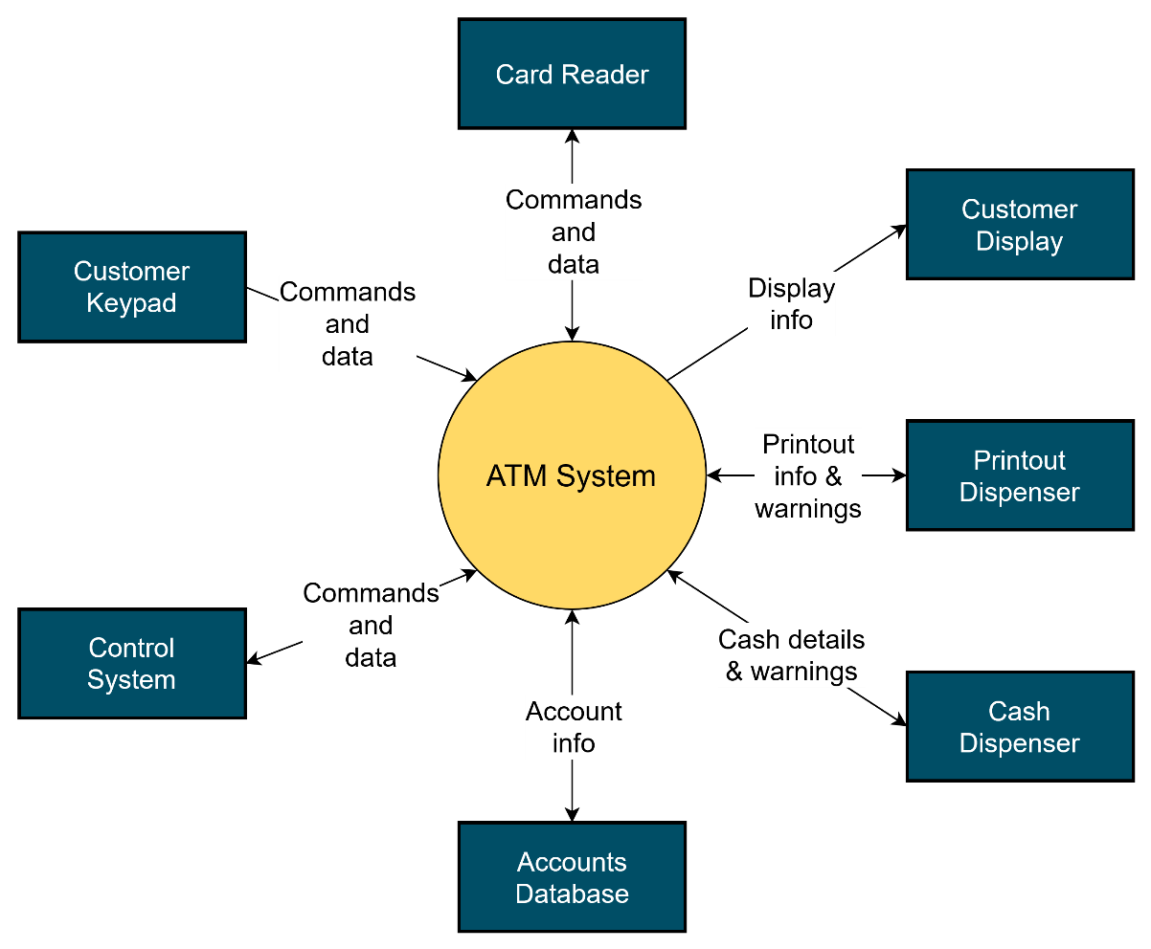

Level 1 Data Flow Diagram
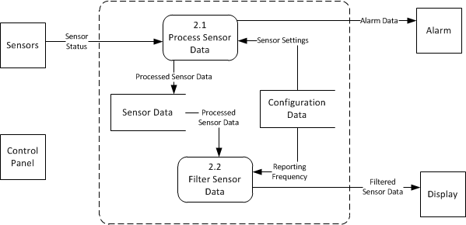

Level 2 Data Flow Diagram
(Diagram here) …

Class Model
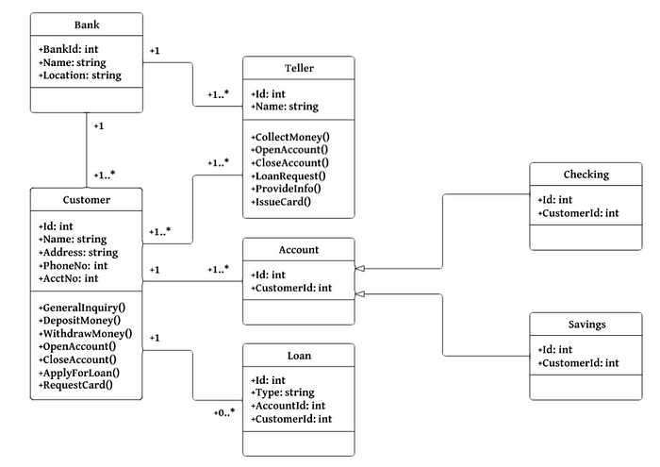

State Model
(Top-level state chart here)

The substate chart for the Logging In state is shown below.
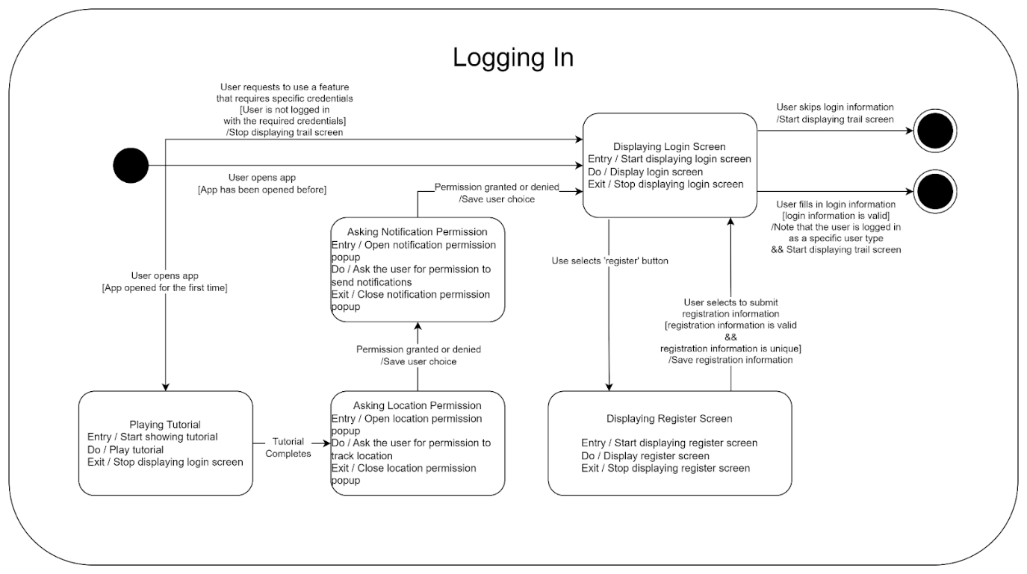

Impact Analysis (10%)
<< This section represents the analysis of impact of your project to global, economic, environmental, societal, and ultimately the health, safety, and security of people. >>

Note: If based on your project, a section would not be applicable, and/or the section would require minimum content, then the grade percentage for that section, will be evenly distributed to other section of the document.

